**Bootstrap 4 Introduction: (Responsive Web Design(RWD))**

Bootstrap 4 is the newest version of Bootstrap, which is the most popular HTML, CSS, and JavaScript framework for developing responsive, mobile-first websites.

**What is Bootstrap?**

Bootstrap is a free front-end framework for faster and easier web development

Bootstrap includes HTML and CSS based design templates for typography, forms, buttons, tables, navigation, modals, image carousels and many other, as well as optional JavaScript plugins

Bootstrap also gives you the ability to easily create responsive designs.

**What is Responsive Web Design?**

Responsive web design is about creating web sites which automatically adjust themselves to look good on all devices, from small phones to large desktops.

**Advantages of Bootstrap:**

**Easy to use:** Anybody with just basic knowledge of HTML and CSS can start using Bootstrap

**Responsive features:** Bootstrap's responsive CSS adjusts to phones, tablets, and desktops

**Mobile-first approach:** In Bootstrap, mobile-first styles are part of the core framework

**Browser compatibility:** Bootstrap 4 is compatible with all modern browsers (Chrome, Firefox, Internet Explorer 10+, Edge, Safari, and Opera).

**CDN(Content Delivery Network):**

If you don't want to download and host Bootstrap 4 yourself, you can include it from a CDN (Content Delivery Network).

MaxCDN provides CDN support for Bootstrap's CSS and JavaScript. You must also include jQuery:

|  |
| --- |
| **<!-- Latest compiled and minified CSS -->**  <link rel="stylesheet" href="https://maxcdn.bootstrapcdn.com/bootstrap/4.3.1/css/bootstrap.min.css">  **<!-- jQuery library -->**  <script src="https://ajax.googleapis.com/ajax/libs/jquery/3.4.1/jquery.min.js"></script>  **<!-- Popper JS -->**  <script src="https://cdnjs.cloudflare.com/ajax/libs/popper.js/1.14.7/umd/popper.min.js"></script>  **<!-- Latest compiled JavaScript -->**  <script src="https://maxcdn.bootstrapcdn.com/bootstrap/4.3.1/js/bootstrap.min.js"></script> |

**jQuery and Popper:**

Bootstrap 4 use jQuery and Popper.js for JavaScript components (like modals, tooltips, popovers etc). However, if you just use the CSS part of Bootstrap, you don't need them.

**Components of jQuery:**

1. Closable alerts
2. Buttons and checkboxes/radio buttons for toggling states
3. Carousel for slides, controls, and indicators
4. Collapse for toggling content
5. Dropdowns (also requires Popper.js for perfect positioning)
6. Modals (open and close)
7. Navbar (for collapsible menus)
8. Tooltips and popovers (also requires Popper.js for perfect positioning)
9. Scrollspy for scroll behavior and navigation updates

**Steps:**

**1. Add the HTML5 doctype:**

Bootstrap 4 uses HTML elements and CSS properties that require the HTML5 doctype.

Always include the HTML5 doctype at the beginning of the page, along with the lang attribute and the correct character set:

|  |
| --- |
| **<!DOCTYPE html>**  **<html lang="en">**  **<head>**  **<meta charset="utf-8">**  **</head>**  **</html>** |

**2. Bootstrap 4 is mobile-first:**

Bootstrap 4 is designed to be responsive to mobile devices. Mobile-first styles are part of the core framework.

To ensure proper rendering and touch zooming, add the following <meta> tag inside the <head> element:

|  |
| --- |
| **<meta name="viewport" content="width=device-width, initial-scale=1">** |

The **width=device-width** part sets the width of the **page** to follow the **screen**-width of the **device** (which will vary depending on the device).

The **initial-scale=1** part sets the **initial zoom level** when the page is first loaded by the browser.

**3. Containers:**

Bootstrap 4 also requires a containing element to wrap site contents.

There are **two container classes** to choose from:

The **.container** class provides a responsive **fixed width container.**

**Example:**



The **.container-fluid** class provides a **full width container**, spanning the entire width of the viewport

**Example:**



**Grid Classes:**

The Bootstrap 4 grid system has five classes:

* .**col-** (extra small devices - screen width less than 576px)
* **.col-sm-** (small devices - screen width equal to or greater than **576px**)
* **.col-md-** (medium devices - screen width equal to or greater than **768px**)
* **.col-lg-** (large devices - screen width equal to or greater than **992px**)
* **.col-xl-** (xlarge devices - screen width equal to or greater than **1200px**)

The classes above can be combined to create more dynamic and flexible layouts.

**Note:** Each class scales up, so if you wish to set the same widths for sm and md, you only need to specify sm.

**Grid System:**

**Responsive Columns Grid System:**

|  |
| --- |
| <div class=*"container"*>  <h1>Responsive Columns</h1>  <p>Resize the browser window to see the effect.</p>  <p>The columns will automatically stack on top of each other when the screen is less than 576px wide.</p>  <div class=*"row"*>  <div class=*"col-sm-3"* style="background-color:*lavender*;">.col-sm-3</div>  <div class=*"col-sm-3"* style="background-color:*lavenderblush*;">.col-sm-3</div>  <div class=*"col-sm-3"* style="background-color:*lavender*;">.col-sm-3</div>  <div class=*"col-sm-3"* style="background-color:*lavenderblush*;">.col-sm-3</div>  </div>  </div> |

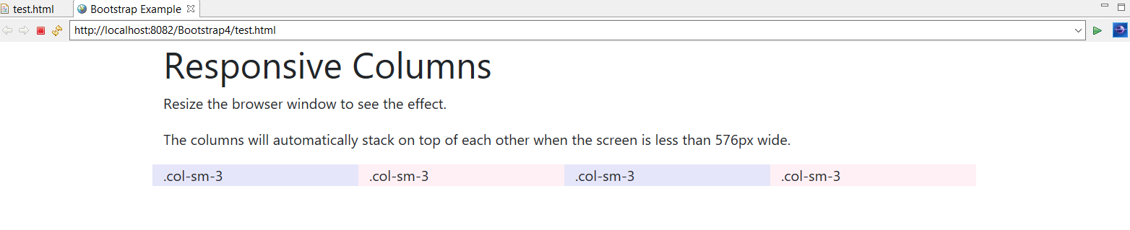

**Two Unequal Responsive ColumnsL**

|  |
| --- |
| <div class=*"container"*>  <div class=*"row"*>  <div class=*"col-sm-4"* style="background-color: *lavender*;">.col-sm-4</div>  <div class=*"col-sm-8"* style="background-color: *lavenderblush*;">.col-sm-8</div>  </div>  </div> |